Ex.no:5 | DATA VISUALIZATION USING MATPLOTLIB

Aim:
To visualize dataset features and distributions using line charts, bar charts, pie charts, histograms, scatter plots, and box plots using Matplotlib.

ALGORITHM 1: LINE CHART
Objective:To visualize the number of tourists across different tourist sites.
Steps
- Load the tourism dataset.
- Count the number of tourists for each tourist site.
- Arrange the tourist sites based on their occurrence.
4. Plot the tourist counts using a bar chart.
5. Add title and axis labels.
6. Display the graph.

Interpretation
The line chart shows how the number of tourists varies across different tour durations and helps identify tourism and travel duration trends.

site_counts = df["Site Name"].value_counts()

plt.figure(figsize=(10,5))
plt.plot(site_counts.index, site_counts.values, marker='o')
plt.title("Number of Tourists by Site")
plt.xlabel("Site Name")
plt.ylabel("Number of Tourists")
plt.xticks(rotation=45)
plt.grid(True)
plt.show()

ALGORITHM 2: BAR CHART
Objective: To compare the number of tourists for different site names.
Steps
- Select the Site Name column.
- Count the number of tourists for each site.
- Create a bar chart using the site names and their tourist counts.
- Add title and axis labels.
- Display the chart.
Interpretation
The bar chart provides a comparison of tourist visits across different sites in the dataset and helps identify the most and least visited tourist sites
site_counts = df["Site Name"].value_counts()
plt.figure(figsize=(7,5))
plt.bar(site_counts.index, site_counts.values)
plt.title("Tourists by Site")
plt.xlabel("Site Name")
plt.ylabel("Number of Tourists")
plt.xticks(rotation=45)
plt.show()
ALGORITHM 3: PIE CHART
Objective: To visualize the distribution of different tourist interests.
Steps
- Select the Interests column.
- Count the occurrences of each tourist interest.
- Calculate their proportions.
- Create a pie chart.
- Display percentage labels.
- Add a suitable title.
Interpretation
The pie chart shows the percentage contribution of each tourist interest to the total number of tourists in the dataset.

import ast
df["Interests"] = df["Interests"].apply(ast.literal_eval)
all_interests = df["Interests"].explode()
interest_counts = all_interests.value_counts()
plt.figure(figsize=(8, 8))
plt.pie(
interest_counts.values,
labels=interest_counts.index,
autopct='%1.1f%%',
startangle=90
)
plt.title("Tourist Interest Distribution")
plt.show()
ALGORITHM 4: HISTOGRAM
Objective: To visualize the distribution of tourist ages.
Steps
- Select the Age column.
- Divide the age values into suitable intervals or bins
- Create a histogram using Matplotlib.
- Add title and axis labels.
- Display the histogram.
Interpretation
The histogram shows the frequency distribution of tourists across different age groups. It helps understand which age groups are most commonly represented among the tourists in the dataset.
plt.figure(figsize=(8,5))
plt.hist(df["Age"], bins=30)
plt.title("Distribution of Tourist Age")
plt.xlabel("Age")
plt.ylabel("Frequency")
plt.show()

ALGORITHM 5: SCATTER PLOT
Objective: To analyze the relationship between tourist age and tourist rating.
Steps
- Select Age as the X-axis variable
- Select Tourist Rating as the Y-axis variable.
- Plot the observations using a scatter plot.
- Add title and axis labels.
- Display the graph.
Interpretation
The scatter plot helps identify whether there is any visible relationship between the age of tourists and their ratings of the tourism sites or experience.
plt.figure(figsize=(8,5))
plt.scatter(
df["Age"],
df["Tourist Rating"],
alpha=0.3
)
plt.title("Age vs Tourist Rating")
plt.xlabel("Age")
plt.ylabel("Tourist Rating")
plt.show()

ALGORITHM 6: BOX PLOT
Objective: To visualize the distribution and identify possible outliers in Tourist Rating.
Steps
- Select the Tourist Rating column.
- Remove missing values if present.
- Create a box plot using Matplotlib.
- Add a suitable title and axis label.
- Display the plot.
Interpretation
The box plot shows the central distribution of tourist ratings and helps identify unusually high or low rating values.

plt.figure(figsize=(7,5))
plt.boxplot(df["Tourist Rating"].dropna())
plt.title("Tourist Rating Box Plot")
plt.ylabel("Tourist Rating")
plt.show()
ALGORITHM 7: MULTIPLE LINE CHART
Objective: To compare total tourists and tourists with low satisfaction across different tour durations.
Steps
- Count total tourists for each Tour Duration.
- Count tourists with low Satisfaction for each tour duration.
- Arrange both datasets in ascending order of tour duration.
- Plot total tourists using a line chart.
- Plot low-satisfaction tourists using another line on the same graph.
- Add labels and a legend.
- Display the graph.

Interpretation
The multiple line chart allows comparison of total tourists with low-satisfaction tourists across different tour durations and helps identify durations with relatively higher dissatisfaction.
Output:
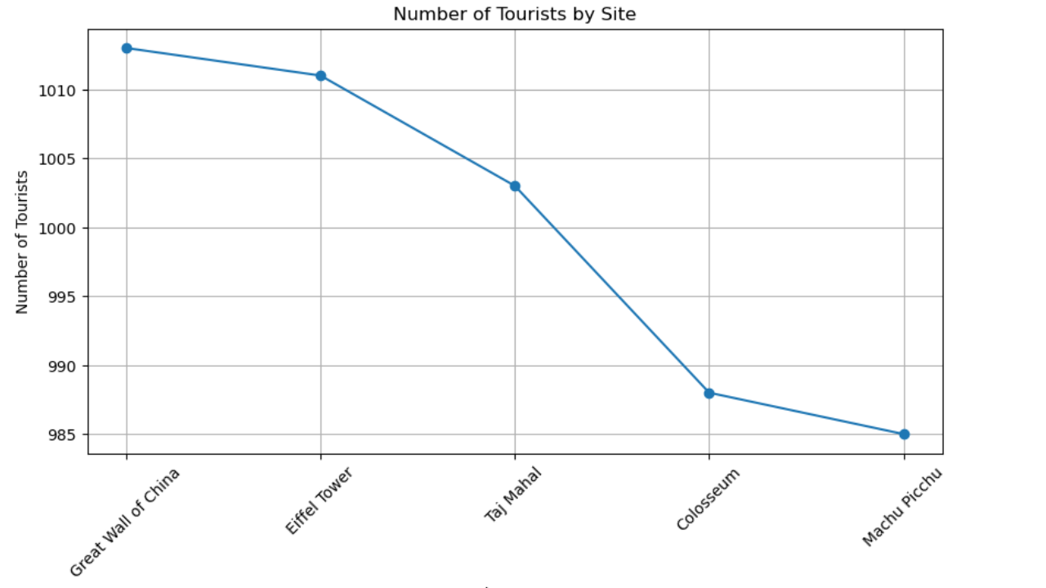

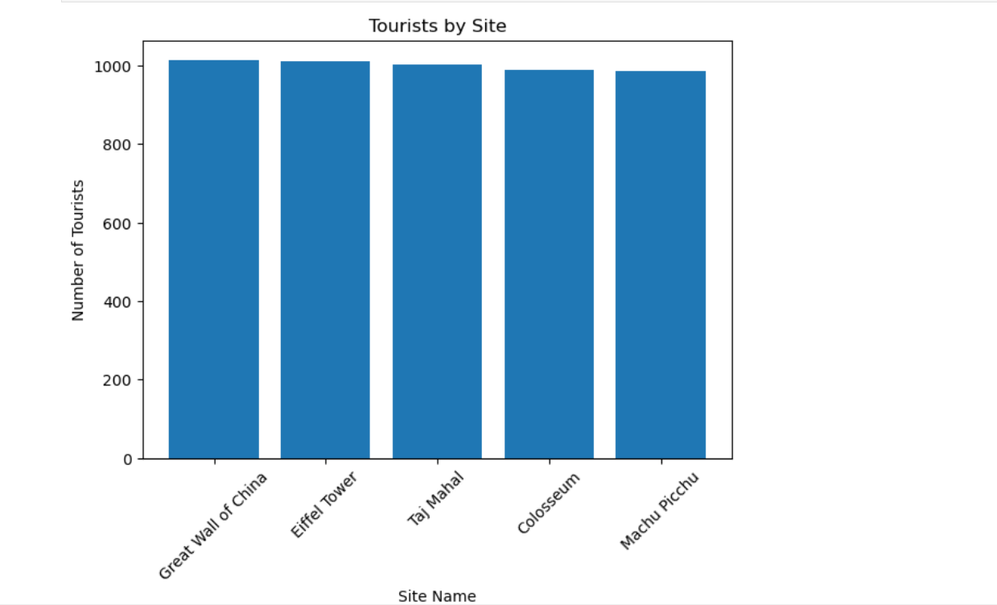

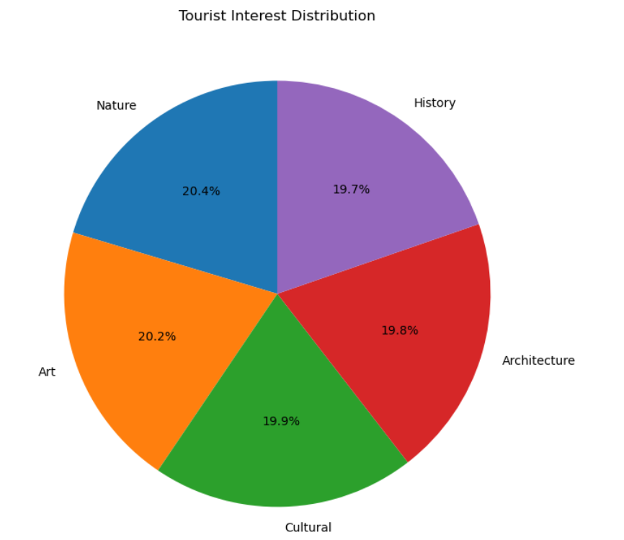

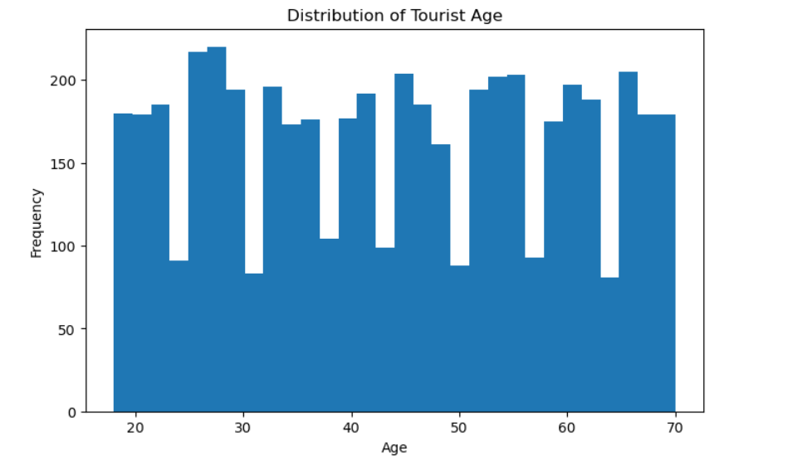

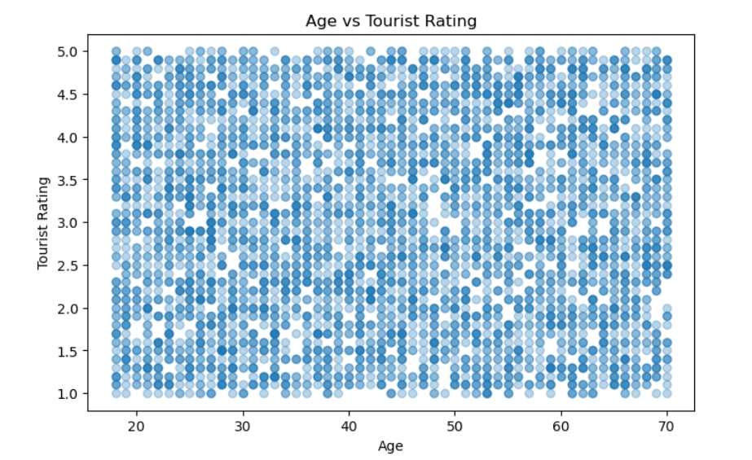
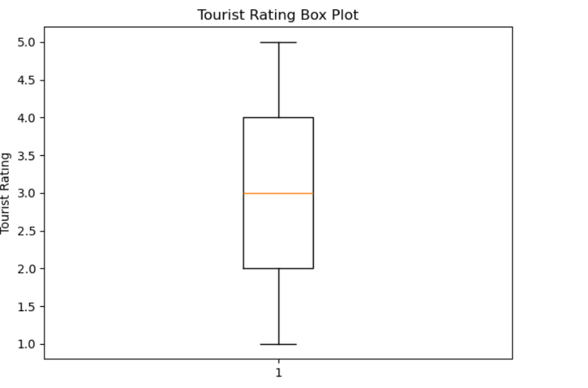

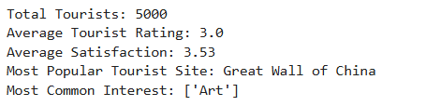
Result:

